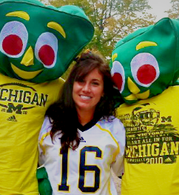
Education

University of Michigan | Ann Arbor Expected Graduation May 2013
Anticipated B.S.S Brain Behavior & Cognitive Science

Experience

Smackwater Development Corporation | Lexington , MI 2005-present
http://www.lexmtc.com/smackwaterblock.html
- Smackwater Deli Tap Room, Smackwater Grille, Brewmaster’s Pub
- Cook, Hostess, Waitress, Bar Tender
- Trained New Employees
- Provided service and prepared facilities for private parties and wedding reservations.
- Responsible for opening and closing the restaurant and bar.

Lexington Music Theatre | Lexington, MI 2007-present
http://www.lexmtc.com/
- Responsible for providing hospitality and accommodations for theatre performers
- Setting up dressing rooms for theatre performers

Independent AdvoCare Distributor 2010 – present

Skills
Very organized, personable, trustworthy, self-motivated, team oriented, work well under pressure. Takes orders well, good communication skills and proficient computer software skills with word processing, spreadsheets, and email. Enthusiastic and eager to learn.

Activities
Member of the Autism Speaks U chapter at the University of Michigan

